**Awareness cum Sensitization Workshop of Viksit Bharat @2047**

Under the banner of Viksit Bharat @2047: Voice of Youth , an Awareness cum Sensitization Programwas organized in the conference hall of GOVT DEGREE COLLEGE KELAM by the Debate and Seminar Committee of the college. The event aimed to make the student participants aware about the Vision of ViksitBharat @2047. The event witnessed the active participation of students and the faculty of the college.

The program was kicked of by the welcome address presented by Prof Suhail Salam Bhat, Head of Dept. Of Education. While addressing the gathering, he highlighted some key aspects of the Vision of Viksit Bharat@2047.

In his scintillating presentation, Prof Kawsar Ahmad Ganie, Head of the Dept. of History discussed the contours of this pan-India program of Viksit Bharat @2047 : Voice of Youth. He elaborated how this program acts as a portal to generate creative ideas by all the stakeholders especially the young student community of the nation. The students were intimated as how to log in the website mygov.in to register themselves and download a certificate thereafter. He impressed upon the students of the college to be a part of this program to propel the nation forward to achieve newer milestones of development in various spheres viz. Education, Healthcare, Technology, Innovation , Entrepreneurship and the like.

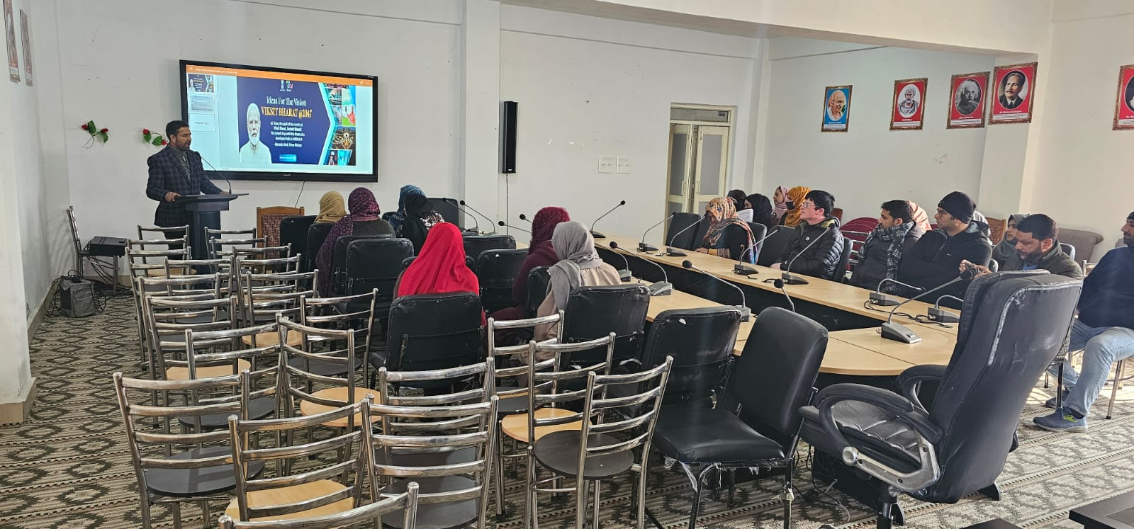

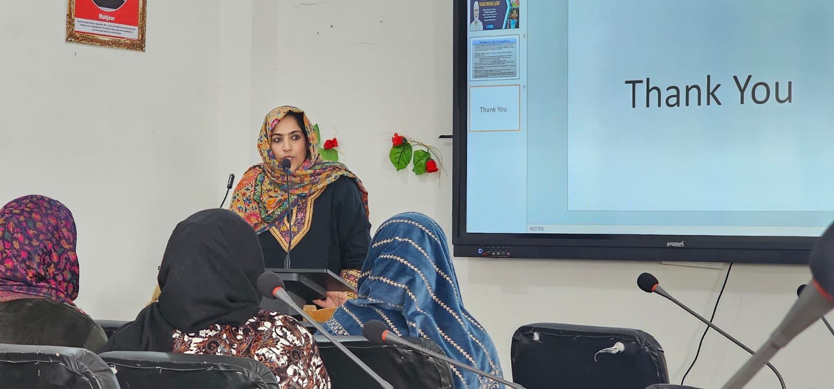

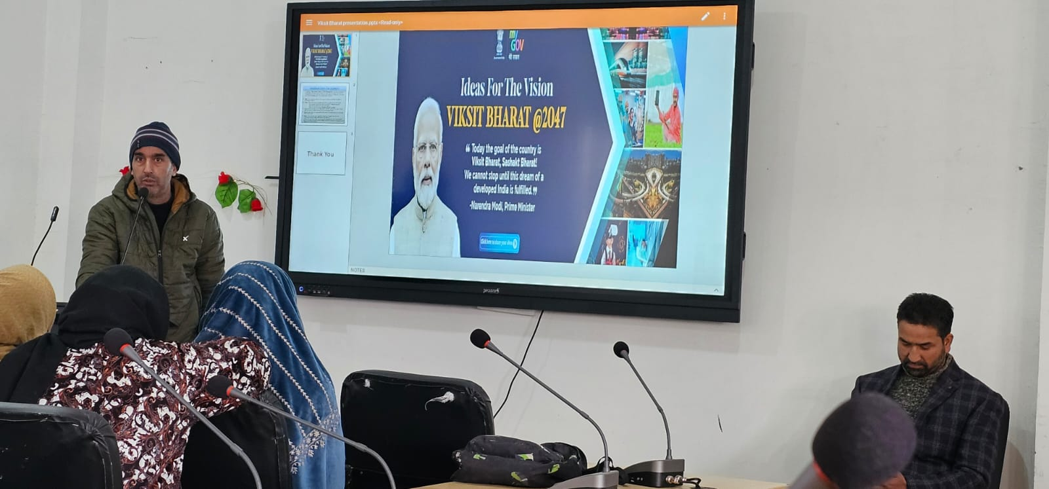

The program culminated with a vote of thanks by Prof Yasira Maqbool, Head of the dept. of Environmental Sciences.