ALTAF MEMORIAL GOVT. DEGREE COLLEGE, KILAM

*(NAAC Accredited Grade “C”)*

**Cell: 9419040661, Telephone : 01931-294562, Email:** [**principalgdckilam@gmail.com**](mailto:principalgdckilam@gmail.com)**, Website: amgdckilam.edu.in**

**National science Day 2024**

The Department of Botany in collaboration with debates and seminar committee of the college under the aegis of Viksit Bharat@2047 organized a one day seminar to celebrate the national science day event in which all the staff members and students participated and acknowledged the role played by the scientific community to lessen the miseries faced by people due to pandemic diseases and other challenges. On the occasion Principal of the college Prof Yasmeen Majid Khan highlighted on the major challenges faced by the civilization and the role scientists play to overcome these problems. She insisted the students to develop the scientific temper and play their role to carry forward the legacy left behind by the great scientists like Sir C. V. Raman. In his address the organizer of the seminar Mr. Siraj Yousuf Parray HOD botany deliberated on the major scientific break troughs such as Genome sequencing, Raman Effect, PCR, Discovery of DNA, Chandrion Mission, Higgs Boson etc which have revolutionized the world. On the occasion many staff members also apprised the importance of developing scientific temper among the young generation and decipher the scientific knowledge to every corner of the society. The programe ended with the vote of thanks by Prof Suhail Salam Bhat.

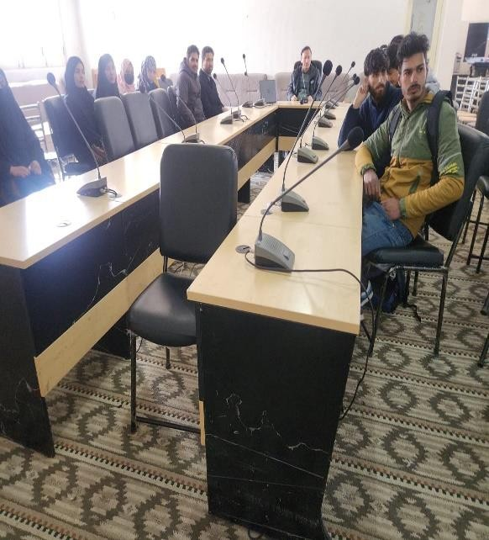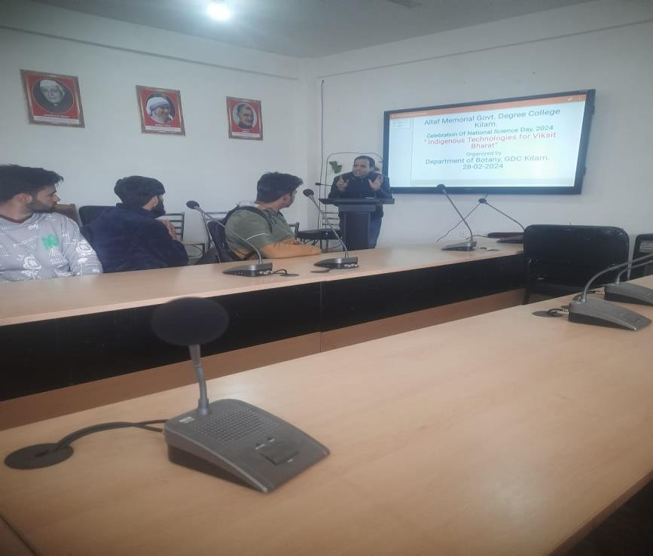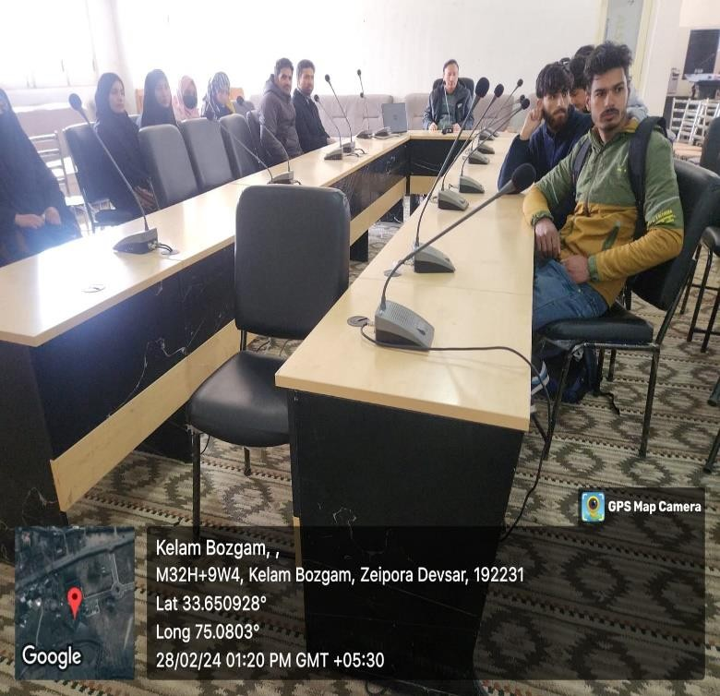

**Convener**

**Principal**