**Report**

The College under the aegis of VIKSIT BHARAT@2047 under able leadership of worthy Principal organized one day sensitization drive on 08/01/2024 from the college campus to main market Kelam. The said drive was conducted with the support of as many as 51 (fifty one) NSS volunteers and Faculty of the College. The worthy Principal of the college flagged off the drive from the campus. The students on the way to the market sensitized people of the area with regard to goals of the Viksit Bharat so as to make India a developed nation by 2047.

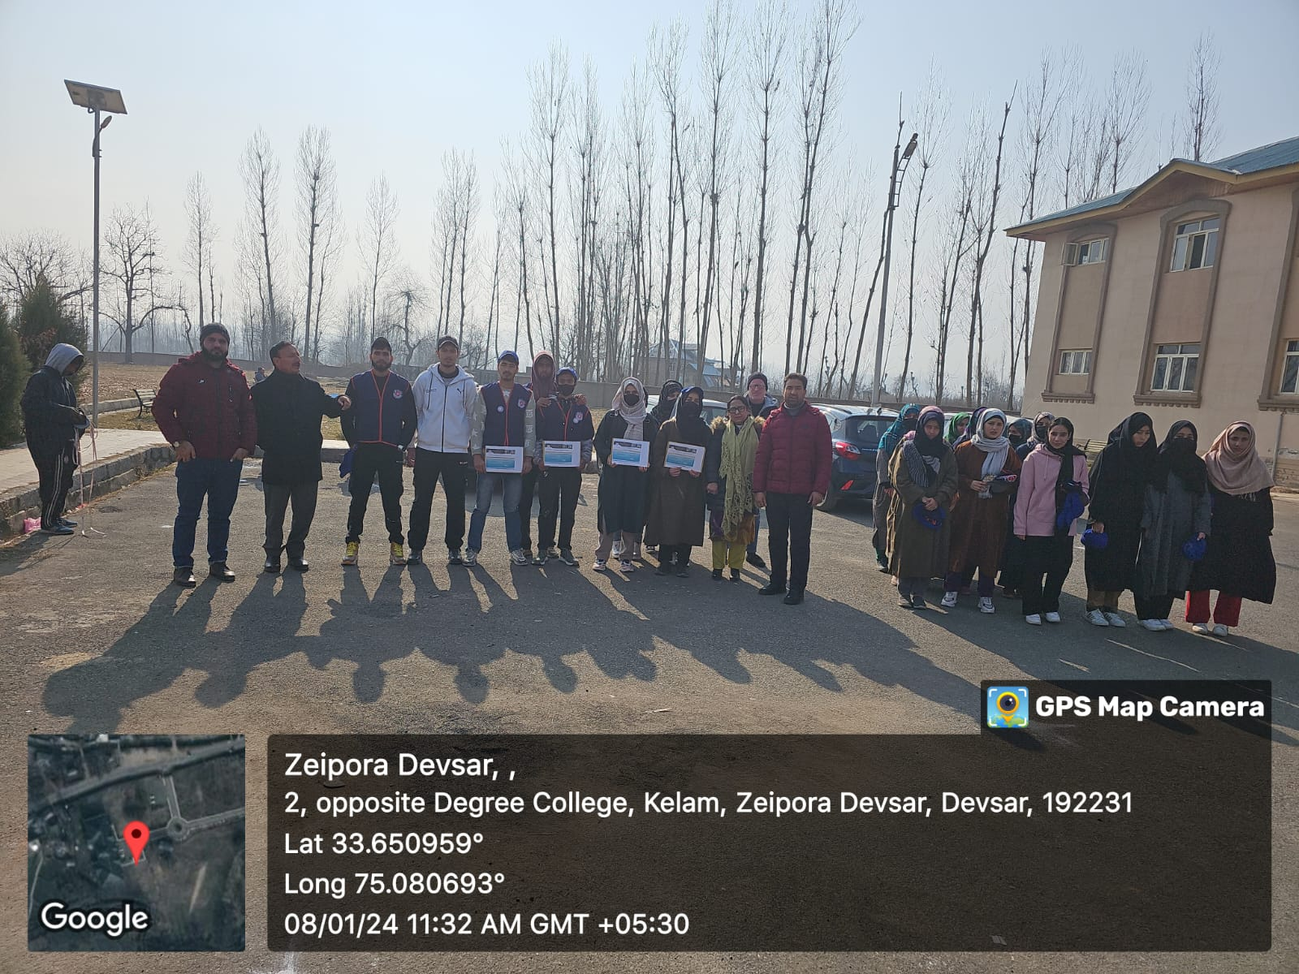

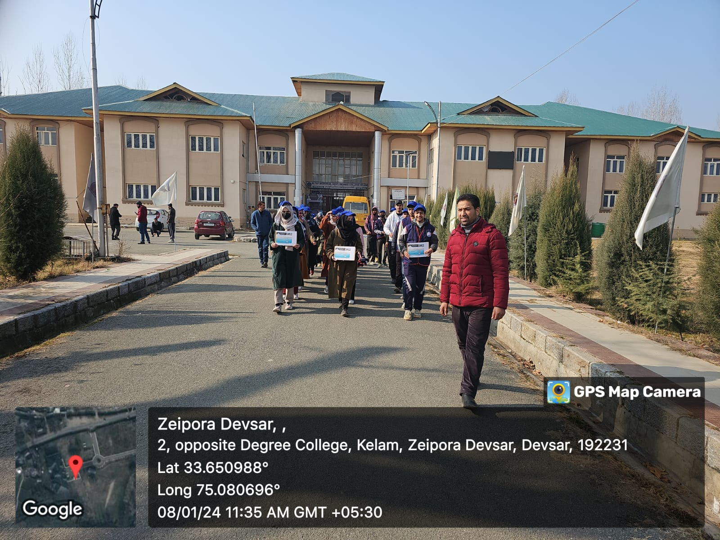

The programme culminated as the students reported back to the college campus. The coordinator of the Viksit Bharat@2047 thanked Principal Madam for her unwavering support, faculty for cooperation and also NSS students for their active involvement despite chilly weather conditions.